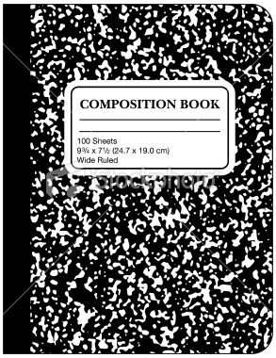
Name _________________________________ Science Chapter __________ Date _____________________
Science Journal Rubric
 | Points Possible | Points Received
Student has specific notes written on right side (teacher input). | 1 point per page
Student wrote their own thoughts on the left side (student output). | 1 point per page
Notes are written neatly | 3 points
Student highlighted notes for studying purposes | 1 point
 |  | Total:

